DC Motor Speed Control with Obstacle Detection

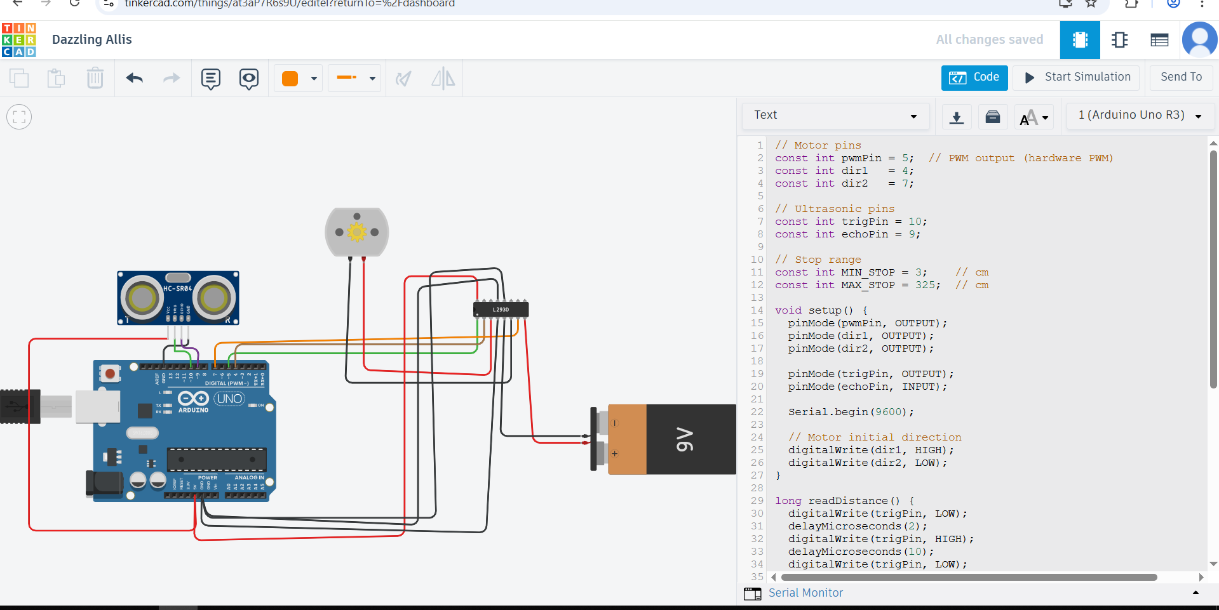

Objective
Control a DC motor speed using PWM and automatically stop the motor when an obstacle is detected within a distance range of 3 cm to 325 cm using an ultrasonic sensor.

DC Motor Speed Control with Obstacle Detection

Objective
Control a DC motor speed using PWM and automatically stop the motor when an obstacle is detected within a distance range of 3 cm to 325 cm using an ultrasonic sensor.

Components
- Arduino UNO (or ESP32)
- L293D Motor Driver
- DC Motor
- HC-SR04 Ultrasonic Sensor
- Breadboard and jumper wires
- External motor power supply (if needed)

Wiring Diagram
+5V
|
VCC
HC-SR04
Trig -> D8
Echo -> D9
GND -> GND

DC Motor -> L293D OUT1 & OUT2
IN1 -> D2
IN2 -> D3
EN1 -> D5 (PWM)
Vcc2 -> Motor power supply (5-12V)
GND -> GND
Notes:
- EN1 pin controls motor speed via PWM.
- IN1 and IN2 control motor direction.
- Trig sends ultrasonic pulses; Echo receives reflected pulses to measure distance.

Code Functionality
- Motor runs forward at a set PWM speed (motorSpeed).
- HC-SR04 continuously measures distance.
- Motor stops if distance ≥ 3 cm and ≤ 325 cm.
- Motor runs normally if no obstacle is detected outside this range.

Test Results (Example)
Distance (cm) | Motor Status
50 | Running
10 | Stopped
330 | Running
3 | Stopped
Observation: Motor responds quickly to obstacles within the defined range, maintaining safety and preventing collisions.
💻 Arduino Code
// Motor pins
const int pwmPin = 5; // PWM output (hardware PWM)
const int dir1 = 4;
const int dir2 = 7;
// Ultrasonic pins
const int trigPin = 10;
const int echoPin = 9;
// Stop range
const int MIN_STOP = 3; // cm
const int MAX_STOP = 325; // cm
void setup() {
pinMode(pwmPin, OUTPUT);
pinMode(dir1, OUTPUT);
pinMode(dir2, OUTPUT);
pinMode(trigPin, OUTPUT);
pinMode(echoPin, INPUT);
Serial.begin(9600);
// Motor initial direction
digitalWrite(dir1, HIGH);
digitalWrite(dir2, LOW);
}
long readDistance() {
digitalWrite(trigPin, LOW);
delayMicroseconds(2);
digitalWrite(trigPin, HIGH);
delayMicroseconds(10);
digitalWrite(trigPin, LOW);
long duration = pulseIn(echoPin, HIGH);
long distance = duration * 0.034 / 2; // cm
return distance;
}
void loop() {
long dist = readDistance();
Serial.print("Distance: ");
Serial.print(dist);
Serial.println(" cm");
// Stop motor if distance is in the 3–325 cm range
if (dist >= MIN_STOP && dist <= MAX_STOP) {
analogWrite(pwmPin, 0); // stop
Serial.println("Motor stopped");
} else {
analogWrite(pwmPin, 200); // run motor at fixed speed outside range
Serial.println("Motor running");
}
delay(100); // 100ms loop
}

